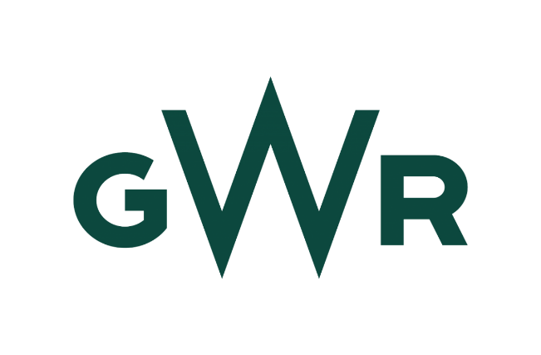

Summary of Requirements for the GWR – Intelligent Management System (IMS).

Supporting Information

Issued by: Great Western Railway

Summary

This Expression of Interest (EOI) is designed to identify any Suppliers that are interested in tendering for the provision of an Open Protocol Intelligent Management System.
GWR require the provision of an Open Protocol Intelligent Management System, for use across GWR's property and Environmental directorates, This proposed solution will facilitate GWR in interfacing with, managing, and monitoring our station property portfolio across various asset types. The primary goal of the IMS is to optimise asset performance within respective environments. GWR require the existing IMS infrastructure including asset devices to remain in situ and utilised as part of any proposal.
The system will be required to, but not limited to, monitor, and where required automate the following:
- Smart meters
- Alarms
- Engineer’s geolocation
- Local weather widgets
- Internet of Things (IoT)
- Asset capture
The contract duration will be for a maximum of 60 months

Indicative Milestone Plan for this tender (Subject to change during the tender process)

Key Milestone | Date
Issue of Expressions of Interest (EOI) | 01/09/2025
Expression of Interest deadline | 29/09/2025
Issue of Tender Document to Tenderers | 30/09/2025
Deadline for submission of Tenderer CQs | 24/10/2025
Deadline for Client responses to submitted CQs | 27/10/2025
Deadline for tender response submission | 31/10/2025
Evaluation of tender responses | 12/11/2025
Tender presentations shortlist announced | 13/11/2025
Tender Presentations (for shortlisted Tenderers) | 19/11/2025 - 28/11/2025
Contract Award Notice issued | 05/12/2025
Standstill period | 8/12/25 - 18/12/2025
Contract Signature | Estimated 23/01/2025

